**Largest of n numbers**

#include <stdio.h>

int main() {

int num[10], n, i, largest;

printf("Enter the limit: \n");

scanf("%d",&n);

printf("Enter the numbers: \n");

for(i=0;i<n;i++){

scanf("%d",&num[i]);

}

for (int e = 0; e < n; e++) {

for (int r = n; r >= 0; r--) {

if (num[e] > num[r]) {

largest = num[e];

}

else if (num[r] > num[e]) {

largest = num[r];

}

}

}

printf("largest number is: %d\n",largest);

return 0;

}

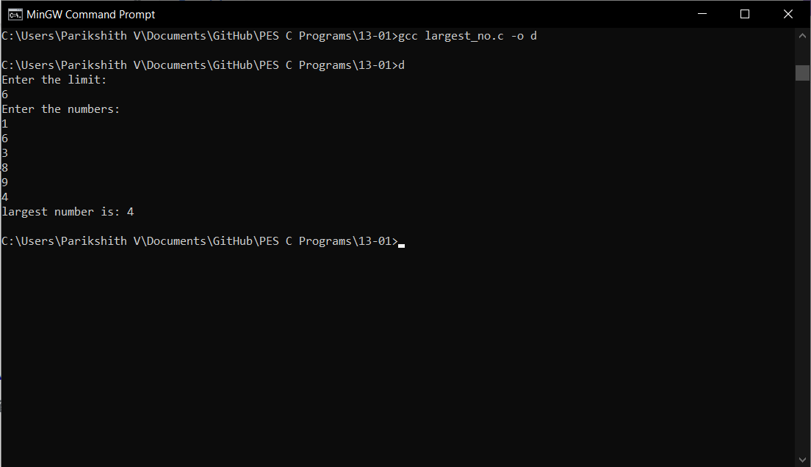

**Smallest of n numbers**

#include<stdio.h>

int main()

{

int a[10], n, i, s;

printf("\n Enter the limit \n");

scanf("%d",&n);

printf("\n enter the numbers: \n", &n);

for(i=0; i<n; i++)

{

scanf("%d",&a[i]);

}

s = a[0];

for(i=1; i<n; i++)

{

if(s > a[i])

{

s = a[i];

}

}

printf("\nsmallest number = %d", s);

return 0;

}

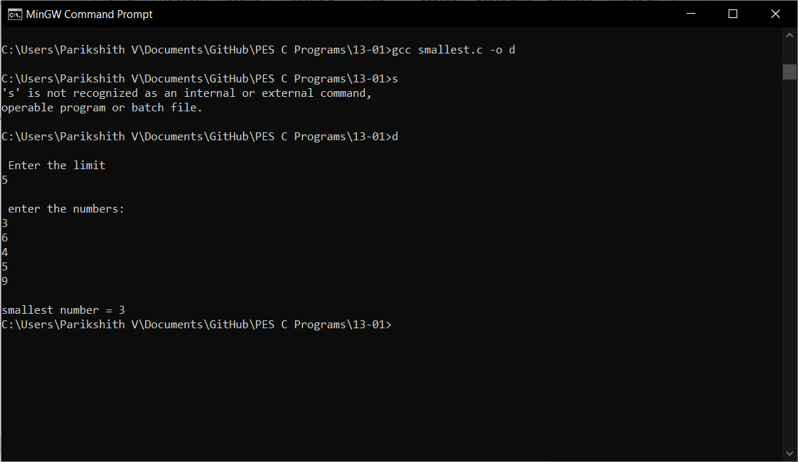

**Sum of n numbers**

#include <stdio.h>

int main()

{

int n,s=0,i;

printf("Enter the limit: ");

scanf("%d", &n);

for (i = 1; i <= n; i++)

{

s = s+i;

}

printf("Sum of the integers is= %d", s);

return 0;

}

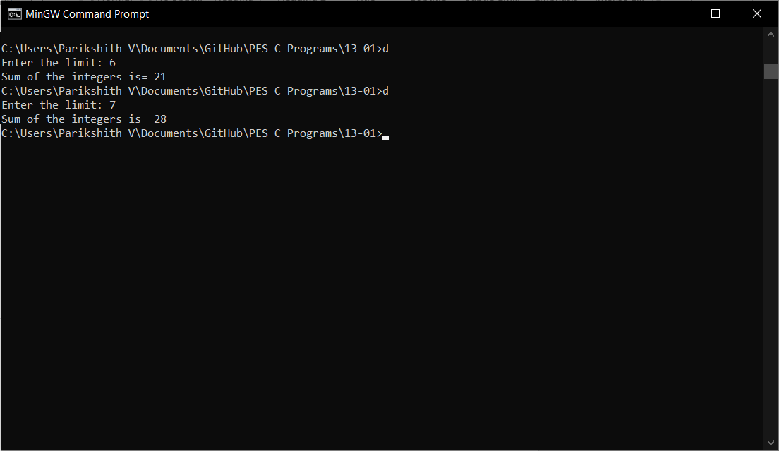

**Numbers divisible by 2 and 3**

#include <stdio.h>

int main(){

int m, n, i=0;

printf("enter the range m < n \n");

scanf("%d",&m);

scanf("%d",&n);

printf("numbers divisible by 2 and 3 are: \n");

for (i=m;i<n;i++){

if (i%2==0 && i%3==0) {

printf("%d, ",i);

}

}

}

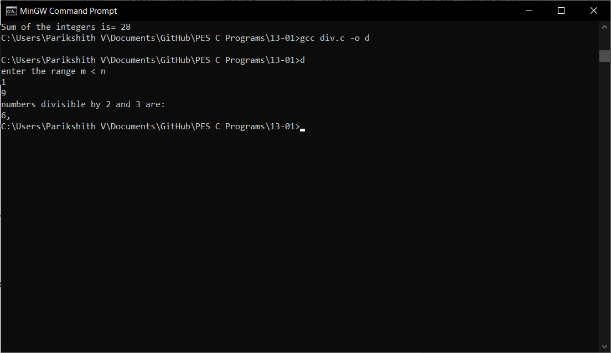

**armstrong numbers**

#include <stdio.h>

#include <math.h>

int main() {

int l, h, number, num, r, arms, count = 0;

printf("Enter numbers l < h: ");

scanf("%d %d", &l, &h);

printf("armstrong numbers between %d and %d are: ", l, h);

for (number = l + 1; number < h; ++number) {

num = number;

while (num != 0) {

num /= 10;

++count;

}

num = number;

while (num != 0) {

r = num % 10;

arms += pow(r, count);

num /= 10;

}

if ((int)arms == number) {

printf("%d ", number);

}

count = 0;

arms = 0;

}

return 0;

}

